Shane Cincotta

CPEG 323 HW #2

11/28/18

ID IF EXE MEM WB

Part 1a) Branches are resolved at the end of the exe stage. If branches are not predicted, we would have to stall for 2 cycles.

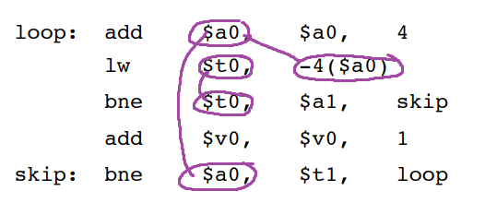Part 1b)

Part 1c)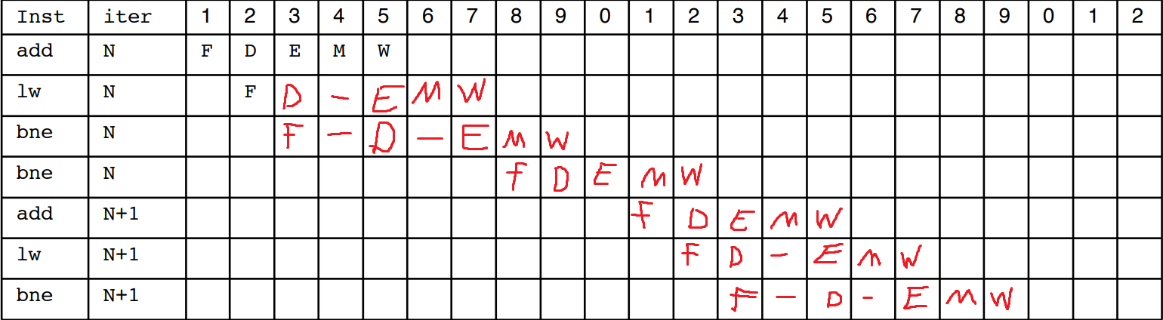

Part 2)